1. Int to Float Conversion
Code:
#include <stdio.h>
int main() {
int a = 10;
float b = a;
printf("%f", b);
return 0;
}
Output:
10.000000
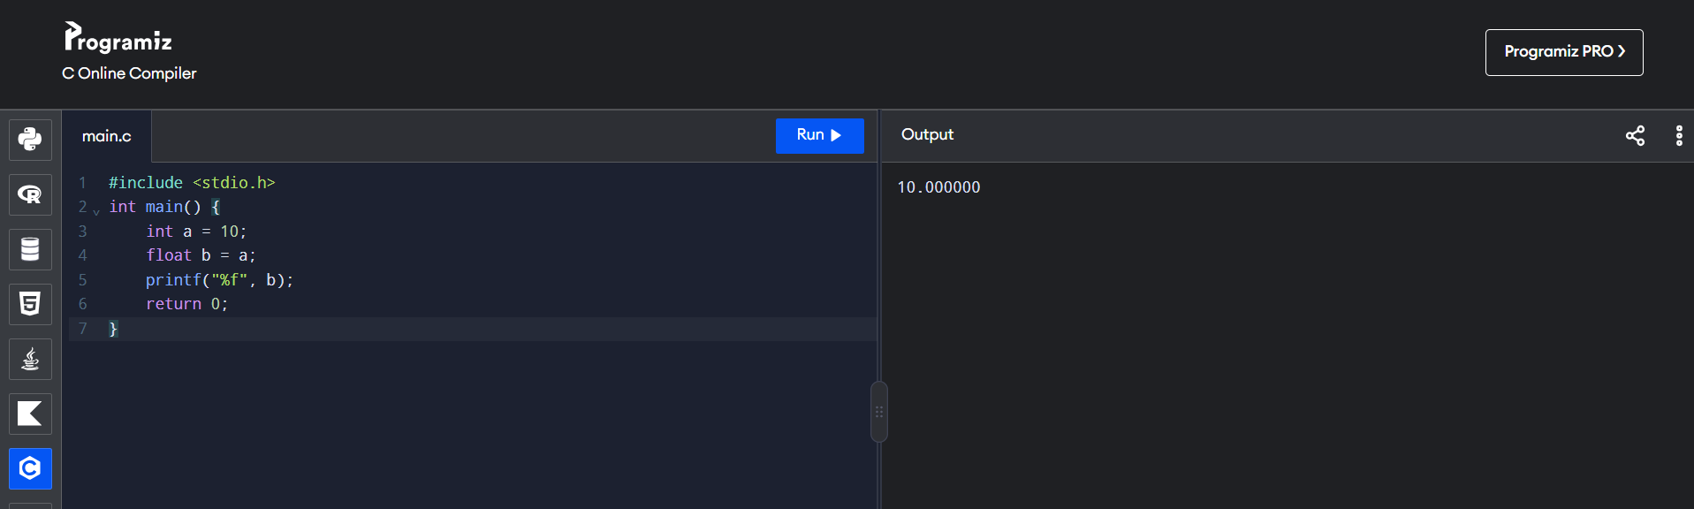

2. Float to Int Conversion
Code:
#include <stdio.h>
int main() {
float a = 10.75;
int b = a;
printf("%d", b);
return 0;
}
Output:
10
